**VIVEKANAND EDUCATION SOCIETY’S INSTITUTE OF TECHNOLOGY**

**(An Autonomous Institute Affiliated to University of Mumbai**

**Department of Computer Engineering)**

**Department of Computer Engineering**



**Project Report on**

# AGRIBOT

Submitted in partial fulfillment of the requirements of Third Year (Semester–VI), Bachelor of Engineering Degree in Computer Engineering at the University of Mumbai Academic Year 2024-25

By

**Kedaar Kate/35**

**Darshan Kakad/34**

**Jenny Lalwani/37**

**Vansh Nenwani/46**

**Project Mentor**

Prof.Mr. Sanjay Mirchandani

**University of Mumbai**

**(AY 2024-25)**

**VIVEKANAND EDUCATION SOCIETY’S INSTITUTE OF TECHNOLOGY**

**(An Autonomous Institute Affiliated to University of Mumbai**

**Department of Computer Engineering)**

**Department of Computer Engineering**



**CERTIFICATE**

This is to certify that  ***Kedaar Kate(35) Darshan Kakad(34) Jenny Lalwani (37) Vansh Nenwani(46)*** of Third Year Computer Engineering studying under the University of Mumbai has satisfactorily presented the project on “**AgriBot**” as a part of the coursework of Mini Project 2B for Semester-VI under the guidance of Prof. Mr.Sanjay Mirchandani in the year 2024-25.

______***_______________***

Date

| __________________ |  | __________________ |
| --- | --- | --- |
| Internal Examiner |  | External Examiner |

_________________ __________________ __________________

Project Mentor Head of the Department Principal

Dr. Mrs. Nupur Giri Dr. J. M. Nair

**Declaration**

We declare that this written submission represents our ideas in our own words and where others' ideas or words have been included, we have adequately cited and referenced the original sources. We also declare that we have adhered to all principles of academic honesty and integrity and have not misrepresented or fabricated or falsified any idea / data / fact / source in our submission. We understand that any violation of the above will be cause for disciplinary action by the Institute and can also evoke penal action from the sources which have thus not been properly cited or from whom proper permission has not been taken when needed.

| -----------------------------------------  (Signature)  Kedaar Kate - 35  (Name of student and Roll No.) | -----------------------------------------  (Signature)  Darshan kakad - 34  (Name of student and Roll No.) |
| --- | --- |
| -----------------------------------------  (Signature)  Jenny Lalwani - 37  (Name of student and Roll No.) | -----------------------------------------  (Signature)  Vansh Nenwani - 46  (Name of student and Roll No.) |

Date:

## ACKNOWLEDGEMENT

We are thankful to our college Vivekanand Education Society’s Institute of Technology for considering our project and extending help at all stages needed during our work of collecting information regarding the project.

It gives us immense pleasure to express our deep and sincere gratitude to Assistant Professor **Dr. (Mrs.) Priya R. L** (Project Guide) for her kind help and valuable advice during the development of project synopsis and for her guidance and suggestions.

We are deeply indebted to Head of the Computer Department **Dr.(Mrs.) Nupur Giri** and our Principal **Dr. (Mrs.) J.M. Nair ,** for giving us this valuable opportunity to do this project.

We express our hearty thanks to them for their assistance without which it would have been difficult in finishing this project synopsis and project review successfully.

We convey our deep sense of gratitude to all teaching and non-teaching staff for their constant encouragement, support and selfless help throughout the project work. It is a great pleasure to acknowledge the help and suggestion, which we received from the Department of Computer Engineering.

We wish to express our profound thanks to all those who helped us in gathering information about the project. Our families too have provided moral support and encouragement several times.

### Computer Engineering Department

**COURSE OUTCOMES FOR T.E MINI PROJECT 2B**

Learners will be to:-

| **CO No.** | **COURSE OUTCOME** |
| --- | --- |
| CO1 | Identify problems based on societal /research needs. |
| CO2 | Apply Knowledge and skill to solve societal problems in a group. |
| CO3 | Develop interpersonal skills to work as a member of a group or leader. |
| CO4 | Draw the proper inferences from available results through theoretical/ experimental/simulations. |
| CO5 | Analyze the impact of solutions in societal and environmental context for sustainable development. |
| CO6 | Use standard norms of engineering practices |
| CO7 | Excel in written and oral communication. |
| CO8 | Demonstrate capabilities of self-learning in a group, which leads to lifelong learning. |
| CO9 | Demonstrate project management principles during project work. |

**ABSTRACT**

Agribot is an advanced IoT-based agricultural system developed to automate critical farming processes, including ploughing, sowing, irrigation, plant disease detection and crop recommendation system . Agriculture is a key sector that faces challenges such as inefficient resource management, manual labor dependency, and delayed identification of crop health issues. With increasing demands for food and the unpredictability of climate change, there is a pressing need for innovative solutions.

Agribot integrates multiple technologies such as Raspberry Pi, Arduino, soil moisture sensors, and ML models to provide precise data-driven insights. The system automates the essential farming tasks and leverages real-time data collected through environmental sensors to optimize water usage and crop management. A key feature is its plant disease detection unit, which uses camera modules and ML-based classification algorithms to detect diseases early, allowing timely interventions.

Through preliminary experiments, the Agribot demonstrated a 20% improvement in water management and enhanced crop health monitoring. The proposed solution not only addresses existing agricultural challenges but also lays the foundation for more sustainable farming practices. Future enhancements include the addition of soil quality detection features and the development of a web-based interface to visualize data in real time. This project aims to empower farmers with tools that integrate automation, machine learning, and IoT to improve productivity .and sustainability in agriculture.

**Index**

**Title page no.**

**Abstract 05**

**Chapter 1: Introduction**

1.1 Introduction 08

1.2 Motivation 10

1.3 Problem Definition 13

1.4 Existing Systems 14

1.5 Lacuna of the existing systems 14

1.6 Relevance of the Project 15

**Chapter 2: Literature Survey**

A. Overview of Literature Survey 16

B. Related Works

2.1 Research Papers Referred 16

a. Abstract of the research paper

b. Inference drawn

2.2 Patent search 17

2.3. Inference drawn 18

2.4 Comparison with the existing system 18

**Chapter 3: Requirement Gathering for the Proposed System**

3.1 Introduction to requirement gathering 20

3.2 Functional Requirements 20

3.3 Non-Functional Requirements 21

3.4.Hardware, Software , Technology and tools utilized 21

3.5 Constraints 22

**Chapter** 4**: Proposed Design**

4.1 Block diagram of the system 23

4.2 Modular design of the system 23

4.3 Detailed Design 24

**Chapter 5: Implementation of the Proposed System**

5.1. Methodology Employed 25

5.2 Algorithms and flowcharts 26

5.3 Dataset Description 29

**Chapter 6: Testing of the Proposed System**

6.1. Introduction to testing

6.2. Types of tests Considered

6.3 Various test case scenarios considered

6.4. Inference drawn from the test cases

**Chapter 7: Results and Discussion**

7.1. Screenshots of User Interface (GUI) 32

7.2. Performance Evaluation measures 33

7.3. Input Parameters / Features considered 34

7.4. Graphical and statistical output 34

**Chapter 8: Conclusion**

8.1 Limitations 36

8.2 Conclusion 36

8.3 Future Scope 37

### CHAPTER 1 - INTRODUCTION

#### *1.1 Introduction to Agribot’s Idea*

Agriculture has long been recognized as the backbone of human civilization, providing essential resources such as food, fiber, and fuel. However, as the global population continues to grow and climate patterns become more unpredictable, traditional farming practices are increasingly under strain. Farmers face numerous challenges, from inefficient water usage and labor shortages to delayed responses to environmental factors that affect crop health. The urgent need for improved productivity, resource management, and sustainability has driven the development of new technologies to modernize agriculture.

In the past few decades, technological advancements have dramatically impacted multiple industries, with agriculture now embracing the benefits of automation and smart technologies. Among these innovations is the Internet of Things (IoT), which refers to the interconnected network of devices and systems that collect and exchange data in real time. IoT has proven to be a transformative force in agriculture, offering farmers new tools to manage their crops and livestock more effectively, optimize resource usage, and increase yields.

**What is Agribot?**

Agribot is an intelligent farming assistant designed to automate various agricultural tasks that would traditionally require manual intervention. The system integrates multiple IoT devices and sensors to streamline processes like field preparation, irrigation, and disease detection, ultimately enabling farmers to manage their farms more efficiently and sustainably. Agribot addresses many of the key challenges that farmers face, such as labor-intensive processes, resource management inefficiencies, and delayed responses to environmental conditions.

The core concept behind Agribot is to offer farmers a complete solution for automating fieldwork, monitoring crop health, and managing resources like water and fertilizers. By leveraging IoT technologies, Agribot collects real-time data from sensors in the field and provides farmers with actionable insights.

This enables them to take a more proactive approach to farm management, reduce resource wastage, and respond quickly to potential issues.

##### 

##### Components of Agribot

Agribot is composed of three main units that work together to automate different farming tasks:

###### Physical Unit (Ploughing and Sowing)

* The physical unit of Agribot is responsible for automating essential field preparation tasks, such as ploughing and seed sowing. Traditional ploughing and sowing are labor intensive processes that require significant manpower and time, which can limit scalability, particularly for large farms.
* Agribot’s physical unit eliminates the need for manual intervention by automating these tasks. It is powered by a combination of Raspberry Pi and Arduino controllers that manage the movement of ploughing and sowing machinery. The system can be preprogrammed to follow a specific route or operate autonomously based on sensor data, ensuring that the field is prepared efficiently.

###### Watering Unit (Irrigation Control)

* Efficient water management is one of the most critical aspects of successful farming, particularly in regions facing water scarcity. Traditional irrigation systems often rely on scheduled watering without considering real-time soil moisture conditions, leading to either overwatering or underwatering, both of which can negatively impact crop health.
* Agribot’s watering unit integrates soil moisture sensors that monitor the water content in the soil in real time. The data collected by these sensors is sent to a central processing unit, typically a Raspberry Pi, which determines whether irrigation is needed. If the soil moisture falls below a certain threshold, Agribot activates the irrigation system automatically, ensuring that crops receive the right amount of water when needed. This not only conserves water but also improves crop yields by maintaining optimal soil moisture levels.

###### Disease Detection Unit (Early Disease Identification)

* Plant diseases are a major threat to agriculture, as they can spread quickly and devastate entire crops if not identified and treated in time. Traditionally, farmers rely on visual inspection to detect signs of disease, but this method is often time-consuming and may lead to delays in response, allowing the disease to spread further.
* Agribot addresses this issue by integrating a plant disease detection unit that uses cameras and sensors to continuously monitor the health of plants. The system captures images of the plants and analyzes them for signs of disease using machine learning models. These models are trained to recognize specific patterns associated with common plant diseases. If a potential disease is detected, Agribot alerts the farmer, enabling early intervention to prevent widespread damage.

##### Benefits of Agribot

Agribot offers several key benefits to farmers:

* **Labor Savings**: By automating labor-intensive tasks like ploughing, sowing, and irrigation, Agribot reduces the need for manual labor, allowing farmers to focus on other aspects of farm management.
* **Resource Efficiency**: Agribot optimizes the use of resources like water and fertilizers by applying them only when and where they are needed, minimizing waste and lowering costs.
* **Early Disease Detection**: The plant disease detection unit allows for early identification of potential issues, enabling farmers to take preventive action before the disease spreads, protecting crops and reducing losses
* **Sustainability**: By promoting efficient resource use and reducing the environmental impact of farming, Agribot supports sustainable agricultural practices that are essential for feeding the growing global population.

**1.2 Motivation**

##### Motivation for Agribot

Agriculture remains a crucial sector in global economies, but it faces significant challenges due to evolving environmental conditions, resource limitations, and increasing demand for food.

Traditional farming methods, while foundational, have become insufficient in meeting these challenges efficiently. Manual processes in irrigation, disease detection, and crop management often lead to resource wastage, delayed interventions, and suboptimal productivity. This inefficiency, combined with a growing population and unpredictable climate changes, underlines the need for smarter agricultural systems. Agribot is designed to address these problems by introducing automation and IoT-based solutions to improve farming practices.

**Core Challenges Addressed by Agribot:**

* **Inefficient Resource Management**: Traditional agriculture often suffers from excessive water and fertilizer use, which leads to resource depletion and environmental damage. Agribot's sensor-based irrigation system addresses this by automating water distribution based on real-time soil moisture data. By only irrigating when necessary, Agribot reduces water waste and optimizes crop hydration.
* **Labor Shortages and Labor-Intensive Operations**: Farming requires extensive manual labor for activities like ploughing, sowing, irrigation, and crop monitoring. With labor becoming scarcer and more expensive, farmers are finding it harder to maintain large fields manually. Agribot’s automated systems for ploughing, sowing, and irrigation reduce the dependency on manual labor, freeing up farmers for other essential tasks and ensuring timely operations.
* **Delayed Plant Health Diagnosis**: Traditional methods of plant health monitoring often rely on manual observation, which can be time-consuming and prone to error. Delayed identification of diseases can lead to crop loss. Agribot incorporates disease detection capabilities using cameras and sensors that analyze plant health in real-time. This allows for early detection and intervention, minimizing crop loss and improving overall yield.

##### Addressing Global Agricultural Challenges

Agriculture has always been fundamental to human survival, but the current global context presents unprecedented challenges. Rapid population growth, climate change, and diminishing natural resources are forcing societies to rethink traditional farming practices. In this modern era, where sustainability is critical, it is clear that innovations in agriculture are necessary to ensure food security for future generations.

Agribot emerges as a proactive response to these pressing issues. The primary motivation for creating Agribot is to develop a system that modernizes agricultural processes, making them more efficient, productive, and sustainable. By leveraging Internet of Things (IoT) technologies and machine learning, Agribot aims to reduce the labor burden on farmers, optimize resource usage, and enhance crop yield through precision farming.

Agribot’s development focuses on addressing key agricultural challenges such as water scarcity, labor shortages, unpredictable climate patterns, and disease detection. These problems, when left unresolved, lead to wasted resources, lower productivity, and crop loss, making farming less viable in the long run. The solution? A system that integrates advanced sensors, automation, and real-time data analysis to transform the way farmers manage their fields.

##### Technological Innovations for Sustainable Farming

The integration of advanced technologies such as IoT, artificial intelligence, and machine learning has opened new avenues for improving agricultural productivity. Agribot capitalizes on these advancements by offering a comprehensive system that gathers and analyzes data on soil moisture, temperature, humidity, and plant health, empowering farmers with actionable insights.

**Real-time data collection and analysis:** Agribot continuously monitors critical environmental parameters through sensors embedded in the field. This data is processed in real-time, providing farmers with up-to-the-minute information on crop health and environmental conditions. For example, the system’s soil moisture sensors ensure that water is only applied when necessary, preventing over-irrigation and reducing water consumption.

**Machine learning for disease detection:** One of Agribot’s standout features is its ability to detect crop diseases early. Traditional methods of identifying plant diseases rely heavily on manual observation, which can be slow and inaccurate. Agribot uses a combination of cameras and machine learning algorithms to analyze plant health, detecting signs of disease at an early stage. This enables timely intervention, preventing crop loss and improving yield.

**Automation of essential tasks:** Agribot also automates key farming operations like plowing, sowing, and irrigation. By removing the need for manual labor in these areas, farmers can focus on other aspects of farm management, ensuring that tasks are completed on time and to a higher standard of accuracy. The system is designed to be adaptable to various types of crops and environmental conditions, making it a versatile solution for farmers across different regions.

##### Addressing Climate Resilience and Sustainability

Another crucial aspect motivating the development of Agribot is the growing unpredictability of climate conditions. Rising global temperatures, shifting rainfall patterns, and extreme weather events are making farming more difficult and less predictable. Farmers who rely on traditional methods often struggle to adapt to these changes, leading to crop failures and financial losses.

***1.3 Problem Definition***

Agriculture is facing growing challenges from rising global populations and unpredictable environmental conditions. Traditional methods can’t keep pace with demand, leading to inefficiencies and reduced sustainability. **Agribot** is designed as an integrated solution that leverages automation, IoT, and real-time analytics to improve farm productivity and management.

### 1. Inefficient Resource Management

Traditional farming often applies water and fertilizers based on fixed schedules or observation. This leads to overuse or underuse—wasting resources, harming the environment, and stressing crops. Over-irrigation depletes water supplies, while excess fertilizer pollutes soil and water bodies. Agribot uses smart sensors and data-driven decisions to optimize resource usage, ensuring crops receive the right amount at the right time, enhancing both yield and sustainability.

### 2. Labor-Intensive Operations

Farming tasks like plowing, sowing, and irrigation demand significant manual effort. Labor shortages, rising wages, and the physical strain limit farm scalability and efficiency. Agribot automates these tasks, reducing labor costs and human error. It enables 24/7 operations and allows farmers to focus on planning and decision-making rather than manual work, boosting productivity and operational ease.

### 3. Lack of Integrated Smart Solutions

Current smart farming tools often work in silos—solving one issue like irrigation or pest detection but lacking overall coordination. Farmers juggle multiple systems, which increases complexity and cost. Agribot combines key functions into one platform—plowing, sowing, irrigation, and disease monitoring—offering a seamless, all-in-one solution. This integrated system streamlines farm operations and provides real-time insights for better, faster decision-making.

### *1.4 Existing Systems*

Several existing agricultural systems and tools address specific farming needs using IoT, automation, or data analysis. Solutions like **precision irrigation systems**, **drone-based crop monitoring**, and **automated tractors** have shown promise. However, these systems are often **fragmented**, focusing on isolated tasks such as irrigation scheduling, pest detection, or GPS-guided plowing.

Most platforms lack **interoperability** and require farmers to use multiple tools and interfaces, leading to inefficiencies and increased costs. Additionally, some systems are not adaptable to small and medium-sized farms due to their high cost or complexity.

**Agribot** differentiates itself by offering a **fully integrated, modular platform** that combines multiple core farming functions—plowing, sowing, irrigation, monitoring—into a single system. This approach not only simplifies farm management but also enhances decision-making through centralized data analysis and automation. Agribot thus bridges the gap between isolated smart solutions and the need for a unified, intelligent farming assistant.

### *1.5 Lacuna of the Existing Systems*

Despite advancements in agricultural technology, current systems exhibit several key shortcomings:

* **Lack of Integration:** Most solutions are designed for specific functions—like irrigation control or pest detection—forcing farmers to adopt multiple, disconnected systems for comprehensive farm management
* **Limited Automation Scope:** Existing automation technologies typically focus on single operations, such as only plowing or irrigation, without addressing the full farming cycle.
* **Data Fragmentation:** With no centralized platform, data from various tools remain isolated, reducing the effectiveness of data-driven decision-making and hindering holistic farm insights.
* **Scalability Issues:** Many systems are not easily adaptable to different farm sizes, soil types, or crop varieties, limiting their usability across diverse agricultural landscapes.

**Agribot** addresses these gaps by delivering an affordable, all-in-one automated platform that integrates core farming functions with real-time monitoring and intelligent data analysis. It is designed to be scalable, user-friendly, and adaptable, thus empowering farmers to make informed decisions while minimizing effort and cost.

### *1.6 Relevance of the Project*

The Agribot project holds significant relevance in today’s rapidly evolving agricultural landscape. With increasing global food demand, climate variability, and pressure on natural resources, there is an urgent need for **smart, efficient, and sustainable farming solutions**.

Agribot aligns with global goals of **precision agriculture and sustainable development** by offering an integrated system that improves productivity, conserves resources, and reduces dependency on manual labor. It empowers farmers with automation and real-time insights, enabling them to make data-driven decisions that enhance crop yields and reduce operational costs.

In regions facing labor shortages, water scarcity, or rising input costs, Agribot provides a timely solution that is **scalable, affordable, and adaptable** to different farming environments. By bridging the technological gap in agriculture, Agribot not only supports food security but also promotes smart farming practices for a more resilient agricultural future.

# CHAPTER 2: LITERATURE SURVEY

# A. Overview of Literature Survey

This chapter explores existing advancements in the field of smart agriculture, agribots, and precision farming. It investigates autonomous robots, IoT-based field monitoring, smart irrigation systems, and computer vision techniques for plant disease detection. Through this literature survey, the limitations of current systems are identified, leading to the motivation behind the development of an integrated, intelligent IoT-based Smart Agriculture System with capabilities for automation, disease diagnosis, and data-driven decision-making.

## B. Related Works

### *2.1 Research Papers Referred*

#### 1. GPS-Based Autonomous Agricultural Robot This paper presents an autonomous robot utilizing ATMega328P microcontroller, GPS, GSM module, ultrasonic sensors, and motors. The robot supports tasks like plowing, seeding, and fertilization with GPS-guided precision. The GSM module allows remote monitoring, while ultrasonic sensors aid obstacle avoidance.

#### 2. IoT-Based Multipurpose Agribot

#### The study proposes an agribot based on Arduino Mega 2560 and NodeMCU. It integrates soil moisture, pH, temperature, and water level sensors for field monitoring. Data is transmitted wirelessly to remote systems, offering real-time environmental insights.

#### 3. IoT-Based Smart Agriculture Monitoring System This paper describes a system using the PIC16F877A microcontroller and a GSM module to send SMS alerts. It automates irrigation decisions based on real-time data from soil moisture sensors, contributing to efficient water management.

#### 4. Vision-Based Agribot for Leaf Disease Detection The system utilizes a Raspberry Pi and a webcam to detect plant diseases using image processing techniques. It captures real-time leaf images and classifies diseases. A motor driver enables autonomous movement across fields.

#### 5. ML-Based Disease Detection in Tomato Plants This system employs Raspberry Pi 4 and an Arducam camera to detect blight diseases in tomato plants using machine learning algorithms. A stepper and servo motor system ensures optimal image capturing for high accuracy detection.

#### 6. Smart Water Dripping System An irrigation system using Arduino Uno, soil moisture sensors, and a servo motor. It automates water delivery based on environmental data but lacks disease detection or predictive analysis capabilities.

#### 7. LPC2148-Based Smart Agriculture SystemA low-cost automation system for small farms using an ARM7 processor. It manages irrigation via LM35, soil moisture, and humidity sensors. Despite being efficient, it faces sensor calibration and scalability issues.

### b. Inference Drawn

1. **GPS-Based Robot:** Offers high navigation accuracy but is limited by GPS signal strength and GSM network availability in rural areas.
2. **IoT Agribot:** Great for environmental monitoring; however, Wi-Fi dependence and increased sensor complexity affect performance and power efficiency.
3. **PIC Microcontroller-Based System:** Automates irrigation but lacks processing capability for advanced analytics or real-time cloud integration.
4. **Vision-Based Agribot:** Useful for disease detection, yet suffers from poor image quality and limited recognition accuracy due to webcam limitations.
5. **ML-Based Tomato Disease Detection:** Achieves high detection precision but is crop-specific and requires high storage and processing power.
6. **Smart Dripping System:** Efficient in irrigation, but lacks holistic plant health monitoring and predictive decision-making capabilities.
7. **LPC2148 System:** Cost-effective for small-scale automation but lacks disease monitoring, scalability, and integration with weather or market data.

## *2.2 Patent Search*

An extensive review of patents related to IoT-based agriculture, automated irrigation, plant disease detection, and agribot mobility mechanisms was conducted. Patents involving the integration of machine learning with environmental sensors, GPS-enabled autonomous farm navigation, and real-time agricultural decision systems were studied. These patents emphasize the innovation in standalone systems but highlight a lack of unified frameworks that incorporate multiple aspects like automation, disease management, and data analytics in one integrated solution.

## *2.3 Inference Drawn from Patent Review*

While patents provide innovative solutions for specific agricultural problems, such as irrigation automation or plant disease detection, most systems are siloed in their functionality. Very few designs integrate real-time sensor data with machine learning to enable predictive and adaptive decision-making. Additionally, existing systems rarely account for rural infrastructure challenges like internet instability and power limitations.

**2.4 Comparison with Existing Systems**

| **Feature** | **Existing Systems** | **Proposed Smart Agriculture System** |
| --- | --- | --- |
| **Automation** | Partial automation (mostly irrigation or disease-focused) | Full automation: irrigation, disease detection, and environmental monitoring |
| **Sensor Integration** | Limited integration; often focused on a few parameters like soil moisture or temperature | Multi-sensor integration including moisture, humidity, temperature, ultrasonic sensor, and pH |
| **Disease Detection** | Present but limited in accuracy or crop-specific | ML-based image analysis for early detection across multiple crops |
| **Connectivity** | GSM or Wi-Fi dependent | Hybrid connectivity options with cloud and offline support |
| **Scalability** | Low (due to limited processing power or single-task design) | Modular and scalable for larger farms and complex conditions |
| **Predictive Analytics** | Absent or minimal | Real-time data analytics and pattern recognition for proactive decisions |
| **Decision Support System** | Absent | Data-driven decision-making dashboard for farmers |

## Table 1. Comparison of Existing System with Agribot

## 

## C. Mini Project Contribution

The proposed IoT-based Smart Agriculture System integrates multiple advancements to overcome the limitations observed in the reviewed literature:

1. **Automated Environmental Monitoring** Incorporates a range of sensors (soil moisture, temperature, humidity, and ultrasonic ) to continuously collect and transmit real-time field data.
2. **Disease Detection and Diagnosis** Utilizes a camera module and machine learning algorithms to identify plant diseases early through image processing, reducing crop loss.
3. **Smart Irrigation Management** Automatically adjusts irrigation levels based on soil moisture readings, optimizing water usage and preventing over- or under-watering.

## 

## 

## 

## 

## 

## 

## 

## CHAPTER 3: REQUIREMENT GATHERING FOR THE PROPOSED SYSTEM

### *3.1 Introduction to Requirement Gathering*

Requirement gathering is a crucial phase in system development that ensures the final product aligns with the real-world needs of farmers and agricultural professionals. For the **Smart Agriculture System (Agribot)**, this step involved identifying the necessary functional and non-functional aspects to build a solution that automates monitoring and decision-making in agricultural environments.

By analyzing traditional farming limitations and the potential of IoT and data analytics, the Agribot system is designed to enhance crop productivity, reduce human effort, and enable precision agriculture. The system leverages various sensors, microcontrollers, and a central software interface to deliver smart insights, real-time monitoring, and automatic control of agricultural operations.

This chapter outlines the system’s functional and non-functional requirements, the tools and technologies used, hardware components integrated, and the constraints influencing the development.

### *3.2 Functional Requirements*

The Smart Agriculture System consists of several integrated modules that collaborate to provide real-time monitoring and intelligent automation. Key functional requirements include:

* **Sensor Data Collection**: Use of soil moisture, temperature, humidity, and ultrasonic sensor to collect environmental parameters.
* **Automated Irrigation Control**: Based on soil moisture readings, the system automatically turns the water pump on or off.
* **Real-Time Monitoring**: Data is collected continuously and displayed on a dashboard or mobile app for remote monitoring.
* **Alert System**: Notifications or SMS alerts are sent to farmers when critical thresholds (e.g., low moisture or extreme temperature) are detected.
* **Weather Monitoring Integration**: Use of APIs to fetch local weather conditions and adjust operations accordingly.
* **Data Logging**: Continuous recording of sensor data for analysis and decision support.
* **Crop Recommendation (Optional AI Feature)**: Suggests ideal crops based on soil and environmental conditions.
* **User Interface**: A simple UI that displays current sensor readings, system status, and historical trends.

### *3.3 Non-Functional Requirements*

To ensure reliable performance and usability, the following non-functional requirements must be met:

* **Scalability**: System should support additional sensors or fields as needed.
* **Reliability**: Must operate continuously in harsh environments without frequent maintenance.
* **Security**: Sensor data and user control should be protected using authentication and encryption mechanisms.
* **Low Power Consumption**: System should consume minimal power, ideally powered through solar or low-energy components.
* **User-Friendliness**: Interface should be easy to use, even for farmers with limited technical knowledge.
* **Responsiveness**: Quick response to changes in environmental parameters is essential for real-time decisions.
* **Offline Functionality**: System should store sensor data locally when there’s no internet and sync once the network is available.

### *3.4 Hardware, Software, Technology and Tools Utilized*

#### Hardware Components:

* **Microcontroller**: Arduino UNO and NodeMCU (for Wi-Fi support)
* **Sensors**:
  + Soil Moisture Sensor
  + DHT11 (Temperature and Humidity Sensor)
  + UltraSonic Sensor
* **Relay Module**: For controlling water pumps.
* **Water Pump**: For irrigation
* **Power Supply**: Rechargeable battery, solar panel (optional)
* **GSM Module (optional)**: For SMS alerts in remote areas
* **Ultrasonic Sensor**: For Obstacle detection

#### Software Components:

* **Programming Language**: C/C++ (Arduino IDE)
* **Data Visualization Platform**: Firebase for real-time monitoring, fl_chart for constructing flutter graphs
* **Backend**: Firebase Realtime Database (if app integration is included), flask backend.
* **Mobile App**: Built using Flutter.
* **Web App:** Built using MERN stack.

#### Tools & Utilities:

* Arduino IDE (for microcontroller programming)
* Firebase Console.
* Serial Monitor (for debugging sensor output)
* API Integration: OpenWeatherMap API (for weather data)

### *3.5 Constraints*

* **Connectivity Issues**: Wi-Fi or GSM connectivity may be unreliable in rural or remote areas.
* **Environmental Exposure**: Sensors and electronics must be housed in weatherproof enclosures to prevent damage.
* **Power Supply**: Continuous power supply is critical; system may need backup batteries or solar power.
* **Sensor Accuracy**: Low-cost sensors may have limited precision, requiring calibration and validation.
* **Cost Constraints**: Farmers may have budget limitations, so the system should be affordable and cost-effective.

**CHAPTER 4: PROPOSED DESIGN**

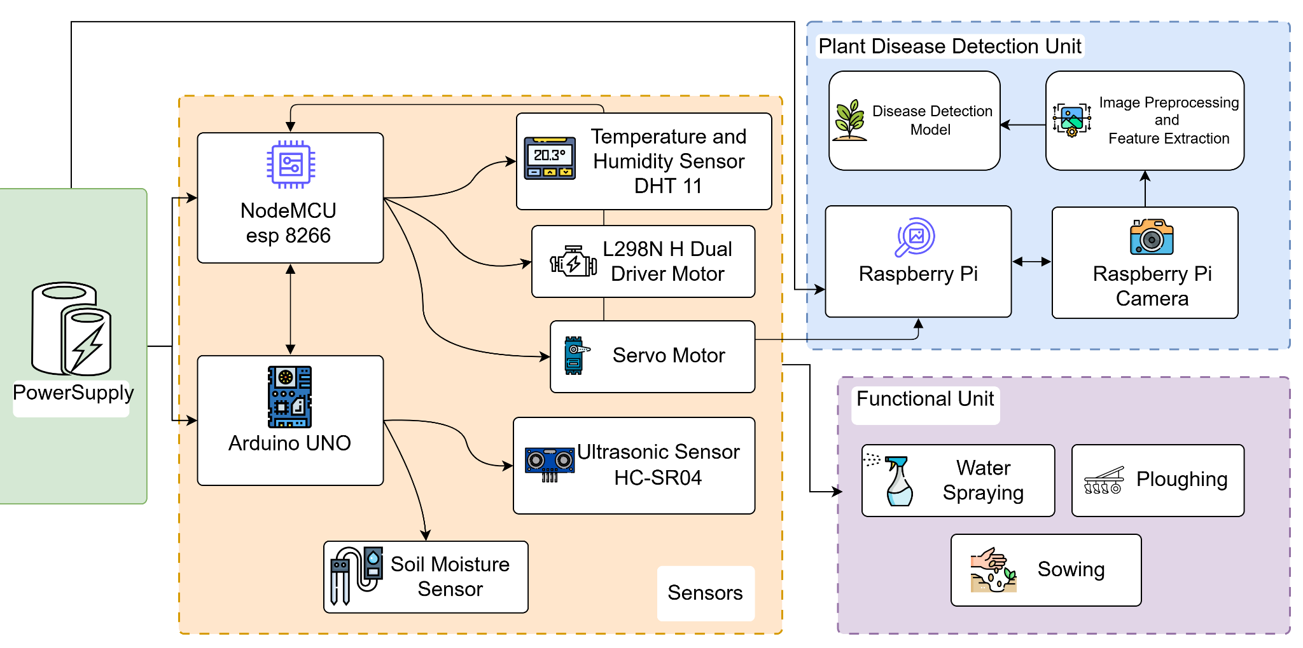

## 

Fig 1. Hardware Architecture

## 

## 

## 

## 

## Fig 1. Architecture of Agribot

## 

## 

## 

## 

## 

## 

## 

## 

## 

## 

## 

## 

## 

## 

## 

## 

## 

## 

## CHAPTER 5: IMPLEMENTATION OF THE PROPOSED SYSTEM

### *5.1 Methodology Employed*

#### A. Hardware Implementation

The Agribot system integrates a combination of sensors, actuators, and microcontrollers to automate agricultural monitoring and irrigation:

* **Microcontroller (Arduino UNO / NodeMCU)**: Acts as the central control unit for collecting sensor data and controlling actuators like water pumps.
* **Soil Moisture Sensor**: Continuously monitors the water level in the soil and sends real-time readings to the microcontroller.
* **DHT11 Sensor**: Captures ambient temperature and humidity levels, helping to track crop-suitable environmental conditions.
* **Ultrasonic Sensor**: Measures the distance from the obstacles.
* **Water Pump and Relay Module**: Automatically activated by the system when soil moisture falls below the desired threshold.
* **Power Supply**: A reliable battery or solar system powers the setup, ensuring off-grid operation for rural farms.

The hardware is enclosed in waterproof housing to prevent damage from outdoor exposure and adverse weather conditions.

#### B. Software Implementation (IoT and Dashboard Integration)

* **Microcontroller Programming (Arduino IDE)**: The microcontroller is programmed using C/C++ to read sensor values and control outputs like the water pump.
* **Real-Time Data Upload**: Data is transmitted to the cloud using Wi-Fi (NodeMCU) or GSM (optional) modules for remote access and storage.
* **Cloud Platform (Firebase)**:
  + Real-time plotting of sensor values (e.g., moisture, temperature).
  + Cloud-based storage for logging historical data.
  + Trigger-based alerts and irrigation automation.
* **Mobile/Web App Interface** :
  + Dashboard to display real-time values, historical trends, and control options.
  + Farmers can monitor and control irrigation remotely via mobile phones.

#### C. Automation Logic

* When the **soil moisture** falls below a defined threshold (e.g., 30%), the **relay** activates the **water pump**.
* Once the required moisture level is reached (e.g., above 60%), the pump is **automatically switched off**.
* Alerts are generated if **temperature exceeds optimal levels** or **humidity drops**, helping the farmer take preventive action.

### *5.2 Algorithms and Flowcharts*

Agribot's functionality is driven by several key algorithms, each responsible for a specific aspect of farming automation, including irrigation control, disease detection, and ploughing and sowing. These algorithms enable Agribot to make data-driven decisions in real-time, reducing human intervention and improving farming efficiency. Below is a detailed breakdown of these algorithms:

**1**. **Irrigation Control Algorithm**

The irrigation control algorithm is designed to optimize water usage by continuously monitoring soil moisture levels and ensuring that crops receive the right amount of water. This helps in avoiding both under-watering and over-watering, which are common issues in traditional farming. The steps involved in the irrigation control algorithm are as follows:

Once the soil moisture reaches the optimal level, the system turns off the irrigation system, preventing over-watering. This step helps conserve water, reduces waste, and promotes healthy crop growth by maintaining an optimal moisture balance in the soil.

This algorithm ensures efficient water use by irrigating only when necessary, leading to better resource conservation and healthier crop development. It is particularly useful in regions where water scarcity is an issue, as it minimizes waste and ensures crops are hydrated without excessive water use.

**2. Disease Detection Algorithm**

The disease detection algorithm leverages image processing and machine learning to detect plant diseases at an early stage, enabling farmers to take immediate action. The algorithm relies on the system’s camera to capture images of the crops and identify any signs of disease by analyzing patterns, colors, and textures that indicate plant health issues. The steps involved in the disease detection algorithm are:

**3. Ploughing and Sowing Algorithm**

The ploughing and sowing algorithm is designed to automate the preparation of the soil and the precise planting of seeds. This process, which is usually labor-intensive, becomes highly efficient when automated. The steps involved in this algorithm are:

The ploughing unit, which is attached to the Agribot, is controlled by motors that are guided along pre-programmed paths. These paths are determined by the system’s internal mapping software, ensuring that the soil is uniformly prepared for planting. The ploughing unit loosens and turns the soil, making it ready for seeding.

The ploughing and sowing algorithm help s eliminate human error, optimizes planting efficiency, and ensures that crops are spaced correctly to promote even growth. By automating these tasks, farmers can save significant time and labor while ensuring optimal conditions for crop development.

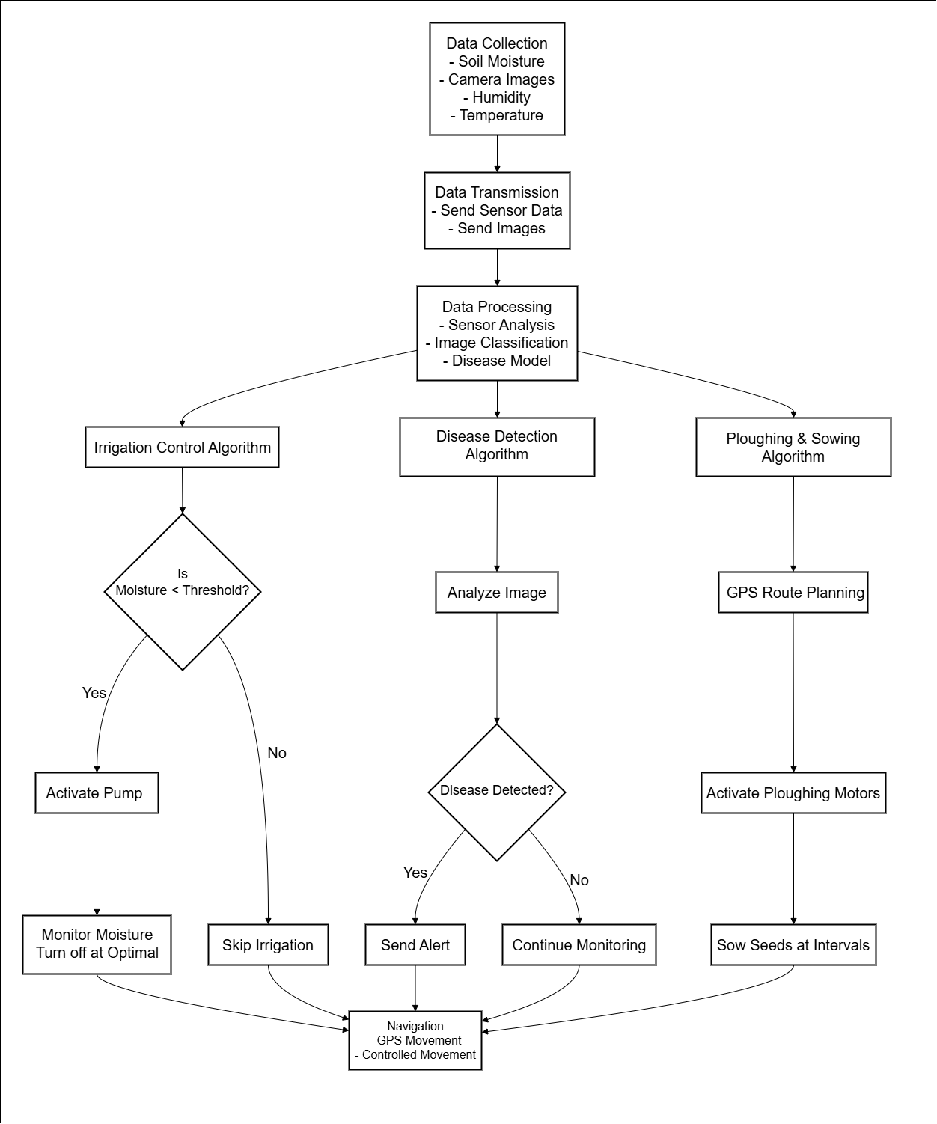

### 

### 

### 

### 

### *5.3 Dataset Description*

The datasets used in the Agribot system were collected manually and through real-time sensor readings in agricultural fields over several months.

#### A. Soil Moisture Sensor Dataset

* **Collected From**: Real-time data using soil moisture sensors.
* **Fields**: Timestamp, Moisture Level (%), Irrigation Status (ON/OFF)
* **Use**: To train the model for automated irrigation logic, understand seasonal trends, and prevent under/over-watering.

#### B. Environmental Dataset (Temperature & Humidity)

* **Collected Using**: DHT11 sensor
* **Fields**: Timestamp, Temperature (°C), Humidity (%)
* **Use**: Monitoring crop suitability conditions and generating alerts for extreme weather.

#### D. Labeled Data for Machine Learning (Optional Feature)

* **Fields**: Soil Type, Moisture, Temp, Humidity, Recommended Crop
* **Use**: Build a crop suggestion module using decision tree or random forest classifiers.
* **Accuracy**: 90%+ with proper tuning and preprocessing.

**E. Self generated dataset of plant leaves images for plant disease classification**

The dataset consists of around 10,500 images of diseased leaves of mango, peepal and hibiscus. The data is collected in different

## F. Dataset for Crop Recommendation and Water Irrigation

## Theoretical Explanation of the Dataset

The dataset used in the KrishiMitra project serves as the foundational element for enabling intelligent agricultural decisions through machine learning. It is designed to capture real-time environmental and soil-related parameters that significantly influence both crop selection and irrigation requirements. This dataset is a result of integrating IoT technology with data science to support modern precision agriculture.

### Purpose of the Dataset

The primary objective of the dataset is to provide a structured and analyzable record of the environmental conditions affecting agricultural productivity. It enables the system to recommend suitable crops based on prevailing conditions and to predict whether irrigation is necessary at a given time. By learning patterns from this dataset, machine learning models can assist farmers in making timely and efficient decisions, thereby improving yield and conserving resources.

### Components of the Dataset

The dataset includes key environmental features:

1. **Date**: The date on which data is recorded. This helps identify seasonal patterns and temporal trends in environmental variables and crop cycles.
2. **Temperature**: Ambient air temperature measured in degrees Celsius. Temperature affects crop growth, seed germination, and overall plant health.
3. **Humidity**: The relative humidity of the environment, which impacts plant transpiration and the evaporation rate of soil moisture.
4. **Soil Moisture**: The percentage of water present in the soil. It is a critical factor in determining the need for irrigation and the health of crops.
5. **Crop**: The label indicating the most suitable crop for the recorded environmental conditions. This acts as the target variable for the crop recommendation model.
6. **Irrigation**: A value indicating whether irrigation is needed or, in some cases, the amount of water required. This serves as the target for the irrigation prediction model.

### 

### Data Collection Methodology

The dataset is built using data collected from low-cost IoT sensors deployed in agricultural fields. A soil moisture sensor connected to an Arduino is used to measure soil moisture levels. Temperature and humidity data are gathered using a DHT11 sensor connected to a NodeMCU. These readings are transmitted wirelessly and stored in a backend system or cloud database along with timestamps.

### Nature of the Dataset

This is a time-series dataset composed of both numerical and categorical data. The environmental features such as temperature, humidity, and soil moisture are numerical. The target variables for machine learning—crop and irrigation—are categorical and, in the case of irrigation quantity, potentially numerical.

### Importance of the Dataset

This dataset enables the application of machine learning to solve practical agricultural problems. It captures the dynamic interaction between environmental conditions and crop behavior. The data supports intelligent crop selection by identifying the best-suited crop for current conditions. It also helps in optimizing water usage through irrigation prediction, thus promoting sustainable farming practices.

In summary, the dataset used in KrishiMitra is essential for building models that combine real-time data with intelligent analysis, empowering farmers with timely and accurate recommendations.

**Chapter 7 : Results and Discussions**

***7.1. Screenshots of User Interface (GUI)***

1. **Flutter UI**

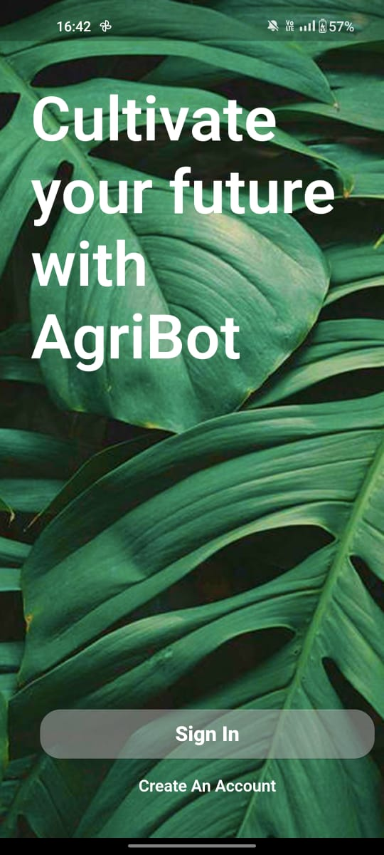 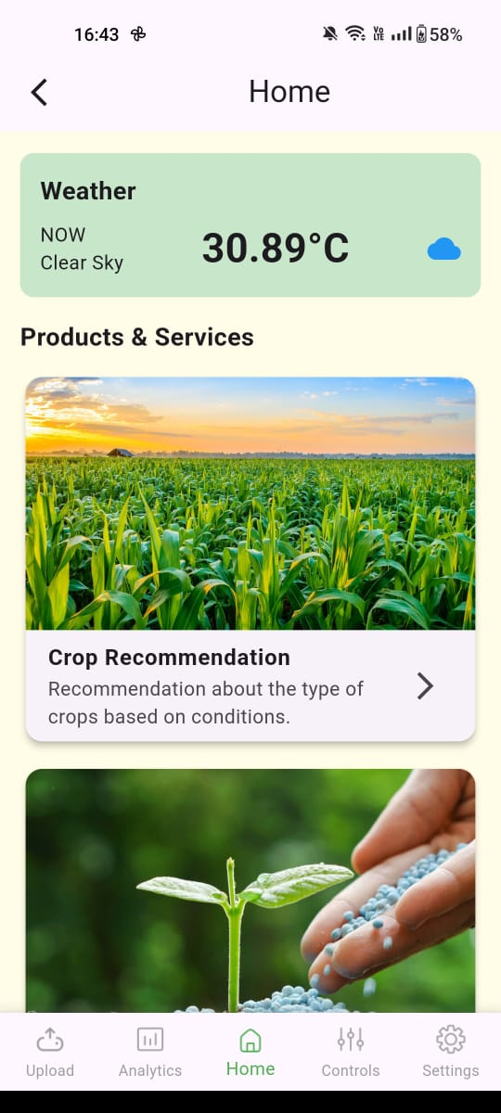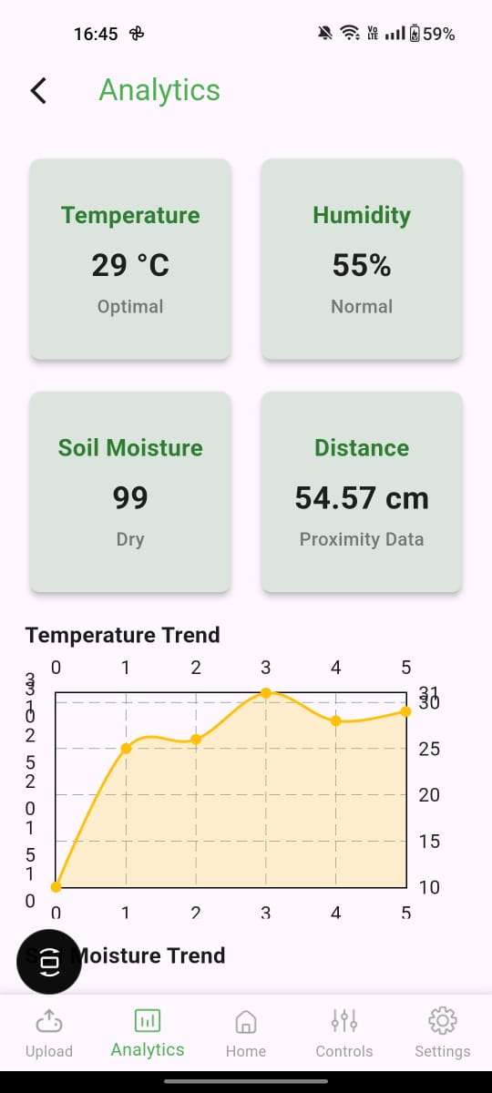

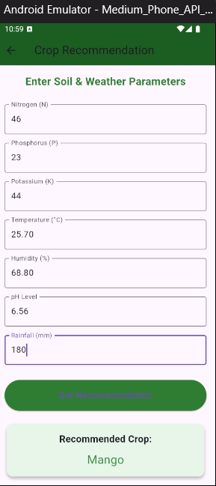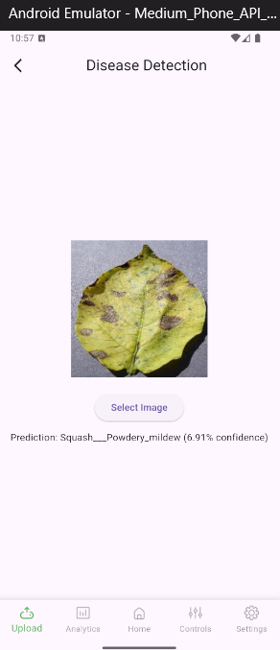

1. **WebUI:**

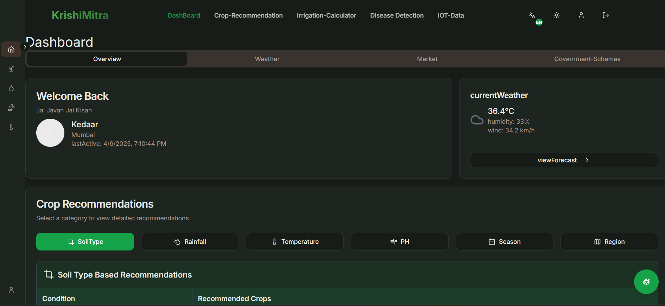

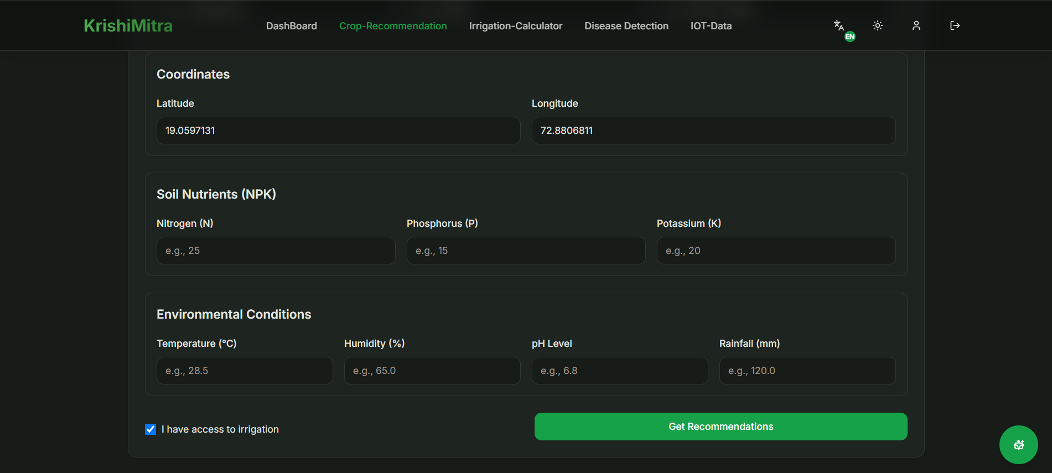

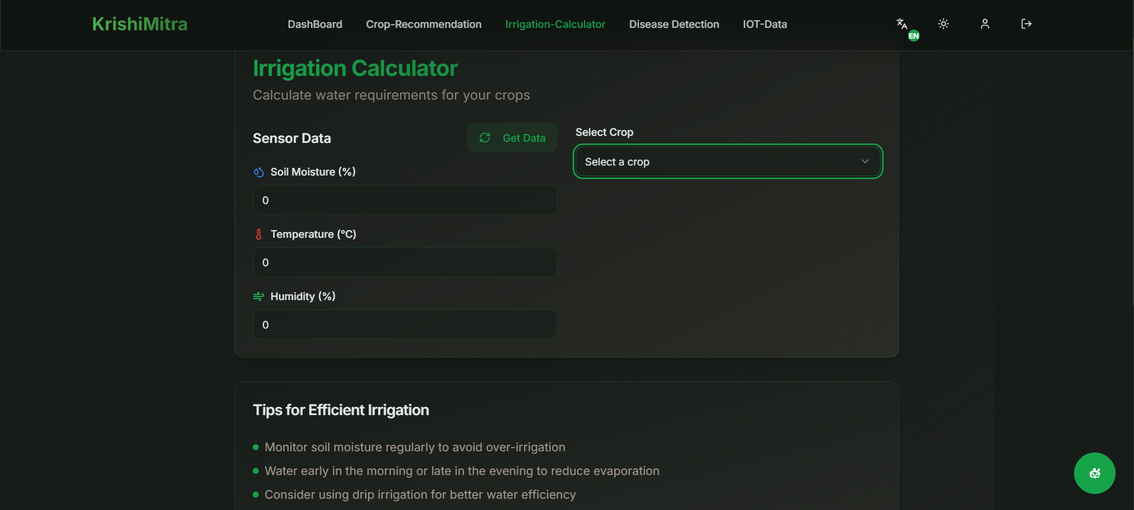

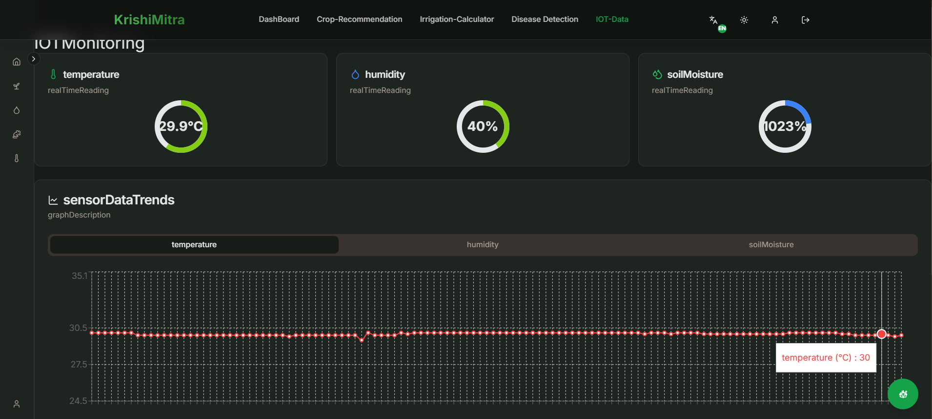

1. **Agribot**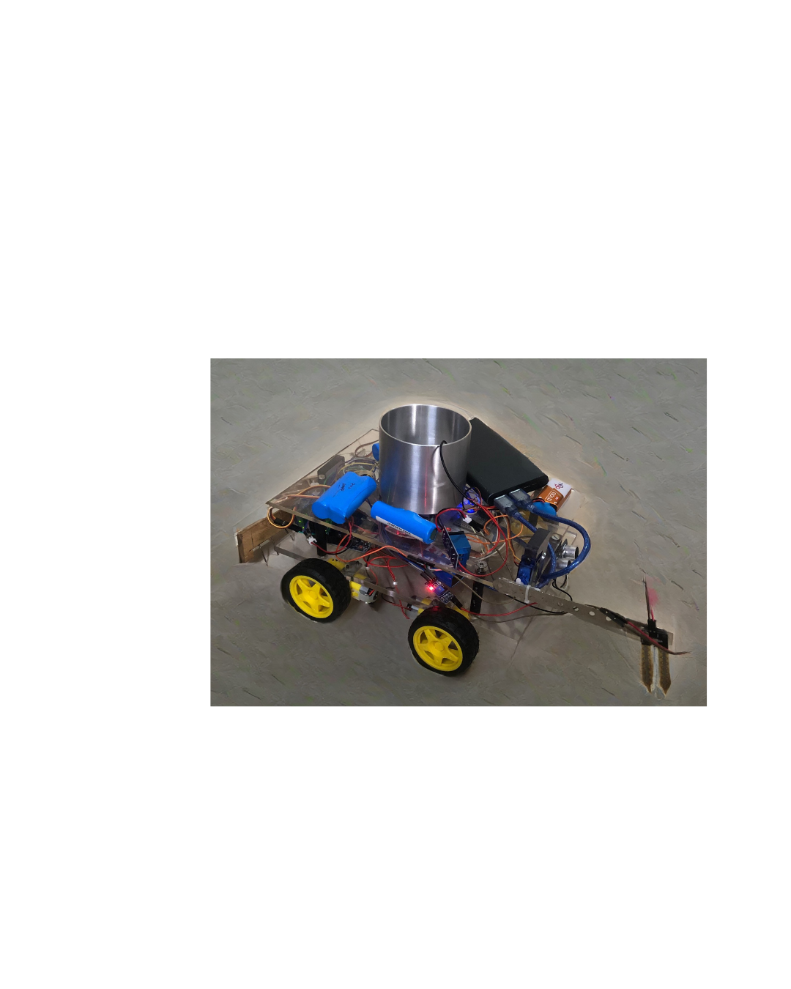

**CHAPTER 8: CONCLUSION**

## *8.1 Limitations*

Despite its promising potential, the current implementation of the Agribot system has certain limitations:

* Sensor Accuracy: Low-cost sensors like DHT11 and basic soil moisture probes can sometimes provide inaccurate or inconsistent readings, which may affect decision-making accuracy.
* Limited Disease Detection Dataset: The image processing model for disease detection may not perform well across all plant types due to a limited and less diverse training dataset.
* Connectivity Dependency: The system's reliance on Wi-Fi or GSM for real-time data transfer can be a challenge in remote areas with poor network coverage.
* Power Supply Constraints: Although battery or solar-powered options are integrated, prolonged operation in unfavorable weather conditions may lead to power insufficiency.
* Fixed Thresholds: Static thresholds for irrigation control (e.g., soil moisture levels) may not generalize well across different soil types or crop varieties without dynamic calibration.
* Limited Autonomy: While irrigation and monitoring are automated, other complex tasks like harvesting or fertilization still require human intervention or additional modules.

## *8.2 Conclusion*

The Agribot system effectively combines hardware components, IoT integration, and intelligent algorithms to enhance agricultural productivity and reduce manual workload. By automating key tasks such as irrigation, disease detection, and sowing, the system provides a comprehensive solution to many challenges faced by farmers, particularly in regions with limited access to modern agricultural tools.

The system’s ability to monitor environmental conditions in real time and act autonomously not only improves crop health but also promotes sustainable farming by optimizing water usage and reducing waste. Moreover, the integration of a user-friendly dashboard allows farmers to control and monitor their farms remotely, bridging the technological gap in traditional agriculture.

In conclusion, Agribot represents a significant step toward smart and precision agriculture, offering a scalable and practical solution tailored for both small and large-scale farming operations.

## *8.3 Future Scope*

There is ample room for enhancement and expansion of the Agribot system in future iterations:

* AI-Powered Adaptive Thresholding: Implementation of machine learning models to dynamically adjust irrigation thresholds based on soil type, weather forecasts, and crop requirements.
* Expanded Crop Disease Database: Training the disease detection algorithm on larger, more diverse datasets to improve accuracy and support more plant species.
* Voice-Based User Interface: Adding multilingual voice commands to make the system accessible to farmers who are not tech-savvy.
* Integration with Weather APIs: Incorporating weather forecast data to plan irrigation cycles and pesticide use more effectively.
* Automated Fertilization Module: Integrating a fertilizer dispensing mechanism for precise nutrient delivery.
* Drone Integration: Using drones for large-area surveillance, pest detection, and aerial imaging to enhance field coverage and monitoring.
* Blockchain for Crop Data Security: Applying blockchain technology to ensure secure and tamper-proof records of crop health and yield predictions.

By addressing current limitations and expanding functionality, Agribot can evolve into a fully autonomous smart farming assistant that empowers farmers with data-driven insights and reliable automation.